Lab task #13

Question #1

#include<iostream>

using namespace std;

int main()

{

int num1, num2;

cout << "Enter num1 : ";

cin >> num1;

cout << "Enter num2 : ";

cin >> num2;

cout << "Required Output is : " << pow(num1, num2);

system("pause");

return 0;

}

Output

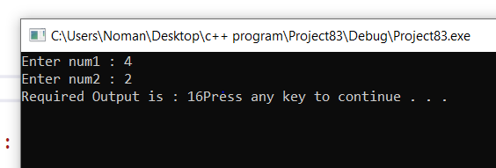

QUESTION #2

#include<iostream>

using namespace std;

int function(int arra[][2])

{

for (int i = 0; i < 2; i++)

{

for (int j = 0; j < 2; j++)

{

cout << arra[j][i]<< " ";

}

cout << endl;

}

return 0;

}

int main()

{

cout << "The transpose of matrix is : " << endl;

int arra2[2][2] = { {1,2},{1,2} };

function(arra2);

system("pause");

return 0;

}

OUTPUT

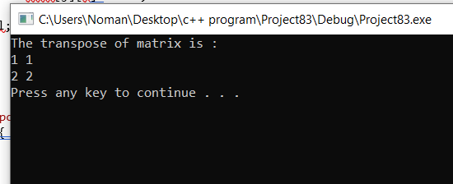

Question #3

#include<iostream>

using namespace std;

int main()

{

int n1 = 2;

int range = 10;

int n2 = 5;

cout << "PLZ enter the range of even odds element :";

cin >> range;

if (n1 % 2 == 0)

cout << "The integer is even " << endl;

else

if (n2 % 3 == 1)

cout << "the integer is odd:";

cout << endl;

system("pause");

}

Output

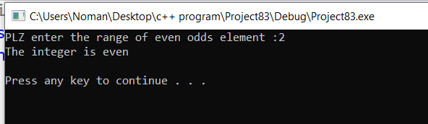

Question #4

#include<iostream>

using namespace std;

int main()

{

int arraymn[2][2] = { { 1,2 },{ 3,4 } };

for (int i = 0; i < 2; i++)

{

for (int j = 0; j < 2; j++)

{

cout << arraymn[0][0];

cout << endl;

}

}

cout << "displaying elements of the arraymn :";

for (int i = 0; i < 2; i++)

{

for (int j = 0; j < 2; j++)

{

cout << arraymn[i][j] << endl;

cout << " ";

}

cout << "sum of arraymn is :";

for (int i = 0; i < 2; i++)

{

for (int j = 0; j < 2; j++)

{

cout << arraymn[i][j];

cout << endl;

}

}

}

system("pause");

}

